Author Guidelines for CEEA-ACÉG Proceedings Manuscripts
Author(s) Name(s)
Author Affiliation(s)
Corresponding Author E-mail Address(es)

Abstract –The abstract is to be in fully justified italicized text, at the top of the left-hand column, below the author information, as it is shown in this stencil. Use the word “Abstract” as the title, in 12-point Times New Roman, boldface type, to the left of the first line, initially capitalized.
The abstract is to be in 10-point, single-spaced type, and may be up 150 words in the original language. Leave one blank line after the abstract, then begin the keywords.
All manuscripts must be in English or French. The body of the abstract should include: (i) background; (ii) purpose (for practice papers) or hypothesis (for research papers); (iii) approach (for practice papers) or design/methodology (for research papers); (iv) outcomes (for practice papers) or results/findings (for research papers); and (v) conclusions. This abstract should refer very closely to the abstract submitted for review to this conference.
Keywords: Type "Keywords" in 10-point Times New Roman, boldface type, initially capitalized, flush left relative to the column, without any number in front of it, followed by a colon (:) and your keywords on the same line. The keywords should list between three (3) and six (6) descriptors of the paper. It is recommended to use the guidelines and keywords provided in the EER Taxonomy (https://taxonomyeecs.wpengine.com/taxonomy/) for a standardized language to facilitate the searchability and visibility of the work. Leave two blank lines after the keywords, then begin the main text.

Introduction
These guidelines include complete descriptions of the fonts, spacing, and related information for producing your proceedings manuscripts. Please follow them, and if you have any critical questions, direct them to the editor in charge of your proceedings at the Canadian Engineering Education Association.
The introduction of your actual paper should include (i) motivation for the paper, (ii) literature review, (iii) problem definition, (iv) solutions considered, (v) selected methodologies, and (vi) significance of the results obtained.
Following this introduction, the entire paper should include (i) the main body, (ii) results and discussion, (iii) conclusions, (iv) acknowledgements, (v) references, and (vi) appendices, if necessary.

Formatting Your Paper

Language of Paper
All manuscripts submitted for inclusion in the conference proceedings must be in English or French.

Length of Paper
The maximum length is eight (8) pages (not including the reference list).

Page Size and Stencil
All printed material, including text, illustrations, and tables, must be kept within a print area of 6–7/8 inches (17.5 cm) wide by 8-7/8 inches (22.54 cm) high. Do not write or print anything outside the print area (except for the required text and page numbers in the headers and footers). Figure 1 illustrates the utilization of a page.
All text must be in a two-column format (except for the main title area). Columns are to be 3-1/4 inches (8.25 cm) wide, with a 5/16 inch (0.8 cm) space between them. Text must be fully justified (except for the title area and references).
This guide has been written in the required format and is made available in Microsoft Word and Adobe pdf formats. A LaTeX version is not available at this time; however, author modification of existing LaTeX conference proceedings styles is acceptable.

Main Title
The main title (on the first page) should begin 1–3/8 inches (3.49 cm) from the top edge of the page, centred, and in 14-point Times New Roman, boldface type, fully capitalized. Further capitalize the first letter of nouns, pronouns, verbs, adjectives, and adverbs; do not further capitalize articles, coordinate conjunctions, or prepositions 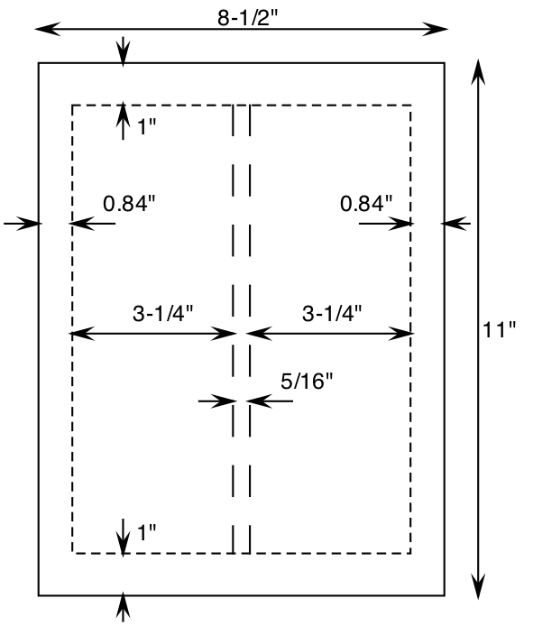
Fig. 1. Page utilization.
(unless the title begins with such a word). Leave two blank lines after the title. Simple paper titles are recommended.

Author Name(s) and Affiliation(s)
Author names and affiliations are to be centred beneath the title, and printed in Times New Roman 11-point, non-boldface type. Each author should be listed by their first and last names. The first name should be spelled out fully, while any middle names could be abbreviated (e.g., John H.T. Smith). Two authors should be separated by “and” (not “&”). Multiple authors should be separated by commas, and the last by “, and.” If the affiliation differs for multiple authors, numerical superscripts can proceed the last names (e.g., John Smith¹), with a corresponding superscript preceding their affiliations (e.g. ¹University of Manitoba). The affiliations are centred below the author names, in 10-point Times New Roman, non-boldface type. Include e-mail addresses of the authors, if possible. Follow the author information by two blank lines before main text.

Preparation for Peer Review
In your draft submission for peer review, do not include any identifying information. This includes not only the authors’ names and affiliations, but also any references in the body of the paper which may indicate the institutions or programs to which the authors belong. Where such information is necessary for the final paper, please replace this content with a note indicating that it has been redacted for peer review. Please also verify that the previously submitted abstract does not include any identifying information. If it does, please edit it accordingly.

Second and Following Pages
The second and following pages should begin 1.0 inch (2.54 cm) from the top edge. On all pages, the bottom margin should be 1-1/8 inches (2.86 cm) from the bottom edge of the page for 8.5 × 11-inch sheet.

Fonts and Type-style
Wherever Times New Roman is specified, Times Roman, or Times may be used. If neither is available on your word processor, please use the font closest in appearance to Times (serif) that you have access to. For text, please avoid using Arial (sans serif) or bitmapped fonts, if possible. True-Type 1 fonts are preferred.

Footnotes
To help your readers, avoid using footnotes altogether, and include necessary peripheral observations in the text (within parentheses, if you prefer, as in this sentence). If you must, place footnotes at the bottom of the column on the page on which they are referenced. Use Times New Roman 8-point type, single-spaced.

Headers and Footers
The header contains the name of the conference, while the footer contains its location, dates, and paper number, all left-justified. The footer also contains the running page number in the paper, and the total number of pages in the paper, both in the format shown. Please ensure you insert your unique paper number.

Formatting the Main Text
Type your main text in 10-point Times New Roman, single-spaced. Do not use double spacing. All paragraphs should be indented 1 pica (approximately 1/6- or 0.17-inch or 0.422 cm). Be sure your text is fully justified; i.e., flush left and flush right. Please do not place any additional blank lines between paragraphs.

First-Order Headings
The main text of the paper is segmented into sections. The heading of each section is called the first-order heading, and it appears, for example, as “3. FORMATTING THE MAIN TEXT”. It is written in Times New Roman, 11-point boldface, all capitalized, centred, with one blank line before, and one blank line after. Use a period (not a colon) after the heading number. Place no period after the heading.

Second-order Headings
As in this heading, they should be Times New Roman, 11-point boldface, initially capitalized, flush left, with one blank line before, and one after.

Third-order Headings. Third-order headings, as in this paragraph, are discouraged. However, if you must use them, use 10-point Times New Roman, boldface, initially capitalized, flush left, preceded by one blank line, followed by a period and your text on the same line.

Text Balancing on the Last Page
If the last page of your paper is only partially filled, arrange the columns so that they are evenly balanced, if possible, rather than having one long column.

Figure and Tables
Figures include line drawings (e.g., flowcharts, network diagrams, schematics, illustrations, and graphs), as well as screenshots and photographs. Figures and tables must be embedded in the text of the paper, with one line above and one line below them.
Figure and table captions should be 9-point Arial (or a similar sans-serif font such as Helvetica). Initially capitalize only the first word of each figure or table caption. Figures and tables must be numbered separately. Figure captions are to be centred below the figures, as shown in Fig. 1. Table captions are to be left justified above the tables, as shown in Table 1.
Table 1: Page dimensions.
Page Elements | Dimensions  [inch]
Page size | 8.5 × 11
Margins  - Top and Bottom  - Left and Right | 1  0.84
Column  - Width  - Spacing | 3.25  5/16

A figure is referenced in text by phrases such as “… as shown in Fig. 1” However, the abbreviated form cannot be used if the sentence starts from “Figure 1 shows …”
All the original figures should be produced using high-quality drawing, or drafting, or image-processor applications such as EazyDraw, Visio, PhotoShop, Illustrator. Screenshots must also be of good quality and legible when placed in the paper. Text in the drawings must be Arial or equivalent sans-serif font. Each figure should fit the column width. If the figure is too complicated, it could fit the width of both columns. Make sure that any text in the figures is not smaller than 8-point when reduced, or 10-point when enlarged.
Each figure should be saved with resolution of 300 dots per inch (dpi), or 150 dpi minimum. Figures with 72 or 96 dpi do not reproduce well. File formats recommended for your figures are .png, .tiff, .bmp for line art, and .jpg, for grayscale or colour photographs. For best results, make the background of the drawing transparent. Vector graphics formats may not be handled well by some word processors. Make sure that the colours selected in the figures could print on grayscale printers, so that any information contained in the colour be also distinguishable when printed.

Preparing Paper for Submission

Saving as a Self-Contained PDF
When saving your paper into Adobe portable file format (pdf) for submission to the conference for inclusion in the proceedings, extreme attention must be given to the display of the file on any screen, and printability of the file on any printer. If the file contains any font that is not available on the displaying computer or a printer, the font may be substituted, and will render the paper unreadable. Consequently, each paper must include and subset the fonts used. The universal fonts include the Times New Roman, Arial, and Symbol.

CEEA-ACÉG Right-to-Publish Form
You must complete the CEEA-ACÉG Right-to-Publish (RTP) form when you submit your full paper. We must receive this form before your paper can be published in the conference proceedings. The RTP form is available on Oxford Abstracts website.
Copyright policy: CEEA-ACEG papers are published open-access, and with a Creative Commons license. Authors retain copyright but must agree to a license. Refer to the form for details.

Acknowledgements
Acknowledge your funding agencies and colleagues involved in the work reported in the paper, but not listed as authors. Do this only once you are submitting the final manuscript, after peer review.
If the research for your paper involved data collected on human subjects, please include a statement indicating that all procedures performed in studies involving human participants were in accordance with the ethical standards of the <name of university research ethics board> per <permit/certificate number>.
References

At the end of your paper, list all the references in an alphabetical order, and number them in 9-point Times New Roman, single-spaced. They should also be reference in the body of the paper - enclose the corresponding citation number in square brackets, for example [1].

[Please note that the examples in the original document have been removed.]

New: As of this year, you should use the current edition of IEEE referencing style to format references. It is available at https://ieeeauthorcenter.ieee.org/wp-content/uploads/IEEE-Reference-Guide.pdf. Citation manager programs (Zotero, Mendeley) will insert references in this style.

- Template & Forms
If an appendix is required, it should be provided immediately after the references. Appendices could include specific examples of algorithm, its code, critical data obtained, and simulation results.
  - CEEA-ACÉG Conference Paper Template
A stencil for a CEEA-ACÉG conference paper (in .doc, and .pdf) is provided at the CEEA-ACÉG Website.
  - CEEA-ACÉG Right-to-Publish Form
CEEA-ACÉG papers are published open-access, and with a Creative Commons license. Authors retain copyright but must agree to a license. A right-to-publish (RTP) form must be submitted for each paper to CEEA-ACÉG prior to the publication of the conference proceedings. Refer to this form for details.
  - CEEA-ACÉG Conference Registration Form
A registration form for the annual CEEA-ACÉG conference is provided at the CEEA-ACÉG Website.
- Quality Assurance
Various organizations have instituted Quality Assurance (QA) processes to ensure the PDF files submitted are acceptable for both print and electronic use. For example, IEEE members can use the IEEE PDF eXpress™ online tool before submitting their final papers. The tool is available at: http://www.computer.org/portal/web/cscps/formatting

