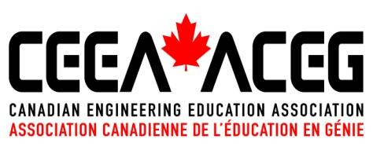

RIGHT TO PUBLISH

- For purposes of this document, the Canadian Engineering Education Association is a membership-driven organization with the role of supporting and encouraging Engineering Education, Research and Practice.
- The undersigned hereby grants CEEA-ACÉG the right to publish in the proceedings of the CEEA-ACÉG Conference to be held June 15-19, 2024, in Edmonton AB, the paper entitled:

Paper Number: ________________
Paper Title: ________________________________________________________________________________________
________________________________________________________________________________________
________________________________________________________________________________________
Authors: ________________________________________________________________________________________
________________________________________________________________________________________
________________________________________________________________________________________
henceforth termed the “Work”.
  - The rights in paragraph 2 include:
    - the right to reproduce the Work by photographic, video graphic, electronic, numeric or by any other process, existing or to be invented, on any support, in color or in black and white;
    - the right to communicate and exhibit the Work to the public by all means, existing or to be invented, including by telecommunication or electronic data transmission;
    - the right to print and to publish the Work in any format or manner, existing or to be invented.
- The undersigned grants the CEEA-ACÉG a worldwide, royalty-free, non-exclusive, perpetual (for the duration of the applicable copyright) license to publish the Work with a Creative Commons Attribution-Non-Commercial 4.0 International (CC BY-NC 4.0) license, which allows others to reproduce, republish, transmit, adapt and translate the Work under the following conditions:
  - That the Authors are attributed;
  - That the reuse not be for commercial purposes.
The details of this license are available at https://creativecommons.org/licenses/by-nc/4.0/.
- The undersigned hereby represents and warrants:
  - that the Work is original;
  - that they are one of the Authors of the Work named above, and that the Authors are the exclusive owner of all rights, including copyrights on the Work and to all images within;
  - that they have been authorized to sign this agreement on behalf of all of the Authors named above;
  - that they have the right to enter into this agreement and to grant CEEA-ACÉG all rights herein granted; and
  - that the Work does not infringe upon any copyright, trade-mark, patent, trade secret or any person or entity.

- Copyright in the Work remains with the Authors and all rights not expressly granted are hereby reserved.

_________________________________________________ ____________________________
Authorized Signature Date

_________________________________________________
Name

______________________________________________________________________________________________
Position

